INDEX

SR. NO. | CHAPTER PAGE NO
5.  6.  7.  8.  9.  10. | SYSTEM DETAILS 2  OIL SELECTION 3  ERECTION & COMMISSIONING 4  MAINTENANCE 5  SEQUENCE OF OPERATION 6  FAULT FINDING & TROUBLE SHOOTING 7  GENERAL M/C ASSEMBLY DRAWING 8  HYDRAULIC CIRCUIT DRAWING 9  ELECTRICAL CIRCUIT DRAWING 10  TEST CERTIFICATE 11

SYSTEM DETAILS

A) 20 TON CAPACITY OPEN & CLOSED MOVEMENT
HYDRAULIC BALING PRESS

- Nature of Power Pack : AC POWER PACK
- Hydraulic Circuit Drg. No. : NIHVA/19-20/0193
- Power pack capacity : 60 LITTER.
- Cylinders : 2 CYLINDER.
- Baling Chamber Size : 1000L X 500W X 1500 HT
- Bale size : 1000L X 500W X 250 - 300H MM
- Working pressure : 180 BAR.
- Operation : ELECTRIC PUSH BUTTON.
- Motor : 5HP,3PHASE,4 POLE 1440 RPM
- Working liquid : 68 GRADE.
- Layout Drg No. : NIHVA/19-20/0096/R03
- Test Certificate No. :

HYDRAULIC CYLINDERS

NATURE OF PRESS CYLINDER

- Types of Cylinder : Double Acting.
- Size of Hyd. Cylinder : Ǿ150X Ǿ125 X 1260 MM Stroke.
3. Stroke : 1260 MM.

NATURE OF TILTING CYLINDER

- Types of Cylinder : Single Acting.
- Size of Hyd. Cylinder : Ǿ60X Ǿ50 X 140 MM Stroke.
3. Stroke : 140 MM.

01. HYDRAULIC OIL SPECIFICATION

HYDRAULIC OIL OF ANY MAKE AS MENTION BELOW.

INDIAN OIL CORPN : SERVO SYSTEM 68
HINDUSTAN PETRLM : EMKLO 68
GULF OIL : GULF HARMONY 68
BHARAT PETRLM : BHARAT HYDROL 68
ELF LUBRICANTS : ACANTIS HM 68
CASTRPL : HYSPIN AWS 68
TIDEWATER : VEEDOL ATLINE 68

- First oil change after 2000 working hours subject to quality of the oil.
- Next oil change for every 2000 working hours.
- Clean suction strainer weekly.
- Always sufficient oil to be maintained in tank as per oil level indicator.

ERECTION & COMMISSIONING

When you receive the hydraulic system, the very first thing you should do is to check the equipment for possible transit damages.

If any damage is noticed, it should be brought to the supplier’s attention immediately.

A minor damage to a vital component, if remains unattended to, will damage the whole system as well as the baling machine.

The next thing to check is the cleanliness of the equipment.

The hydraulic system must always be kept absolutely clean from outside as well as inside.

All hydraulic components are precision made components and for their proper functioning, it is absolutely necessary that they work in a clean environment.

Level the equipment to maximum possible accuracy.

Make the necessary electrical connections and pipe connections.

Open the oil tank inspection windows and inspect the interior of the tank.

The inside of the tank must be free from dirt, dust, cotton lint’s or any foreign material. Foreign particles in the oil will damage the hydraulic system.

After ensuring that the tank is absolutely clean, fill in fresh hydraulic oil into the tank.

When this is done the system can be loaded by gradually increasing the setting of the pressure regulator valve to its full value.

It is quite likely that some of the pipe fittings may show slight oil seepage. This is due the bedding of the sealing elements in the couplings. Tighten such fittings to eliminate seepage. Now your Power pack is ready for operation.

MAINTANANCE

Following points must be strictly observed for trouble free running of the system.

- Keep the system meticulously clean and tidy.

- Use proper grade of hydraulic oil.

- Change the oil after about 1000 working hours for the first refill then at a regular interval of about 2000 working hours.

- Do not allow any unauthorized person to tamper with the controls.

- Maintain proper and genuine spare part stock for replacement.

- Clean suction strainer periodically. For this remove the strainer from the pump through the inspection window provided near the pump and cleans the same in fresh kerosene.

- While replacing a valve, seals or spare part, use original spares from equipment manufacturer. Spares manufactured as a “Make Shift” arrangement may permanently damage the valve as well as the equipment.

SEQUENCE OF OPERATION

- TURN ON MAIN SWITCH.
- KEEP MOVING PLATE AT TOP END POSITION BEFORE FILL UP THE MATERIAL. (ALL DOOR MUST BE CLOSED WHILE TAKING MOVING PLATE AT TOP MOST POSITION).
- WHILE OPERTING THE MACHINE MOTOR ROTATION SHOULD BE IN CLOCKWISE DIRECTION.
- OPEN FEEDING DOOR AND MAKE SURE THAT MAIN DOOR IS CLOSED.
- FEED SCRAP MATERIAL UNIFORMLY INSIDE THE CHAMBER.
- DO NOT FEED ANY HARD OR TOUGH MATERIAL ALONG WITH BALE MATERIAL INSIDE THE CHAMBER.
- DON’T APPLY TANGENTIAL LOAD AFTER FEEDING OF SCRAP MATERIAL AT ONE SIDE OF THE CHAMBER.
- PRESS DOWN BUTTON SUCH THAT MAIN RAM COMES DOWN UNTIL SET PRESSURE IS REACHED. (NOTE: -THE MAIN DOOR, FEEDING DOOR AND TILTTING PALTE LIMIT SWITCH MUST BE OPERATE.)
- AFTER GETTING SET PRESSURE AND REQUIRED BALE SIZE, OPEN ALL DOORS OF M/C.
- WITH THE HELP OF POKER (BAR) AND BINDING MATERIAL TIE BALE TIGHTLY.
- THEN PRESS UP BUTTON AND TAKE RAM TO THE TOP END POSITION.
PRESS TILT UP BUTTON TO EJECT BALE, THEN PESS TILT DOWN
BUTTON SUCH THAT TILTTING PATE SHOULD BE PALCED AT BOTTOM
END POSSITION. (NOTE: - THE MAIN CYLINDER LIMIT SWITCH MUST BE
OPERATE.)
- REPEAT SAME PROCEDURE FOR NEXT BALE.

FAULT FINDING AND TROUBLE SHOOTING

FAULT | CAUSE | REMEDY
1. Cylinder not opening | a) Open pipe connection.  b) Valve malfunctioning  c) Worn out pump rectifies.  d) Suction valve damaged. | Check and rectify  Check and rectify  Check and replace  Check and rectify
2. Main ram creeping  while the lifter is idle | a) Delivery valve damaged.  b) Release valve damaged. | Check and rectify  Check and rectify
3. Pump does not give flow. | a) Insufficient oil in the tank.  b) Worn out plunger seals. | Check and replace  Check and replace

GENERAL M/C ASSEMBLY DRAWING

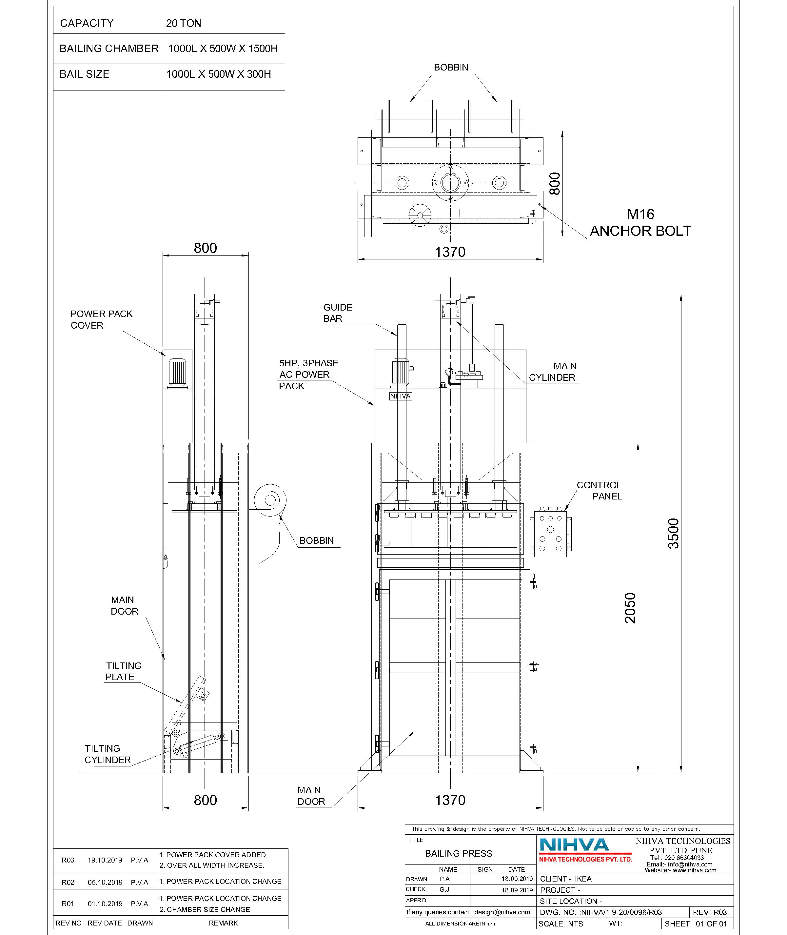
HYDRAULIC CIRCUIT

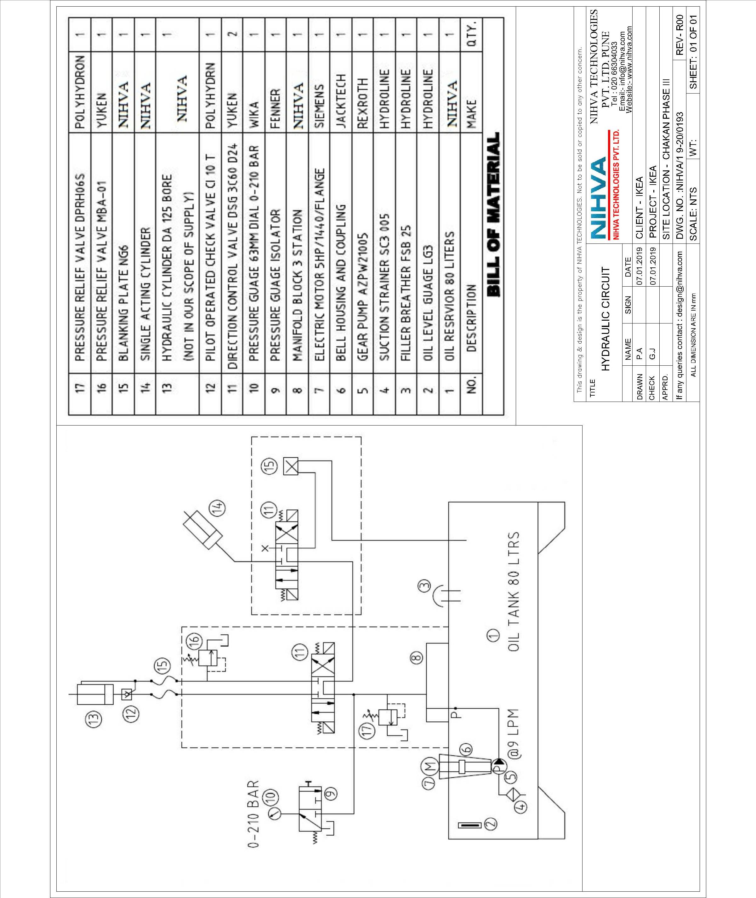

ELECTRIC CIRCUIT

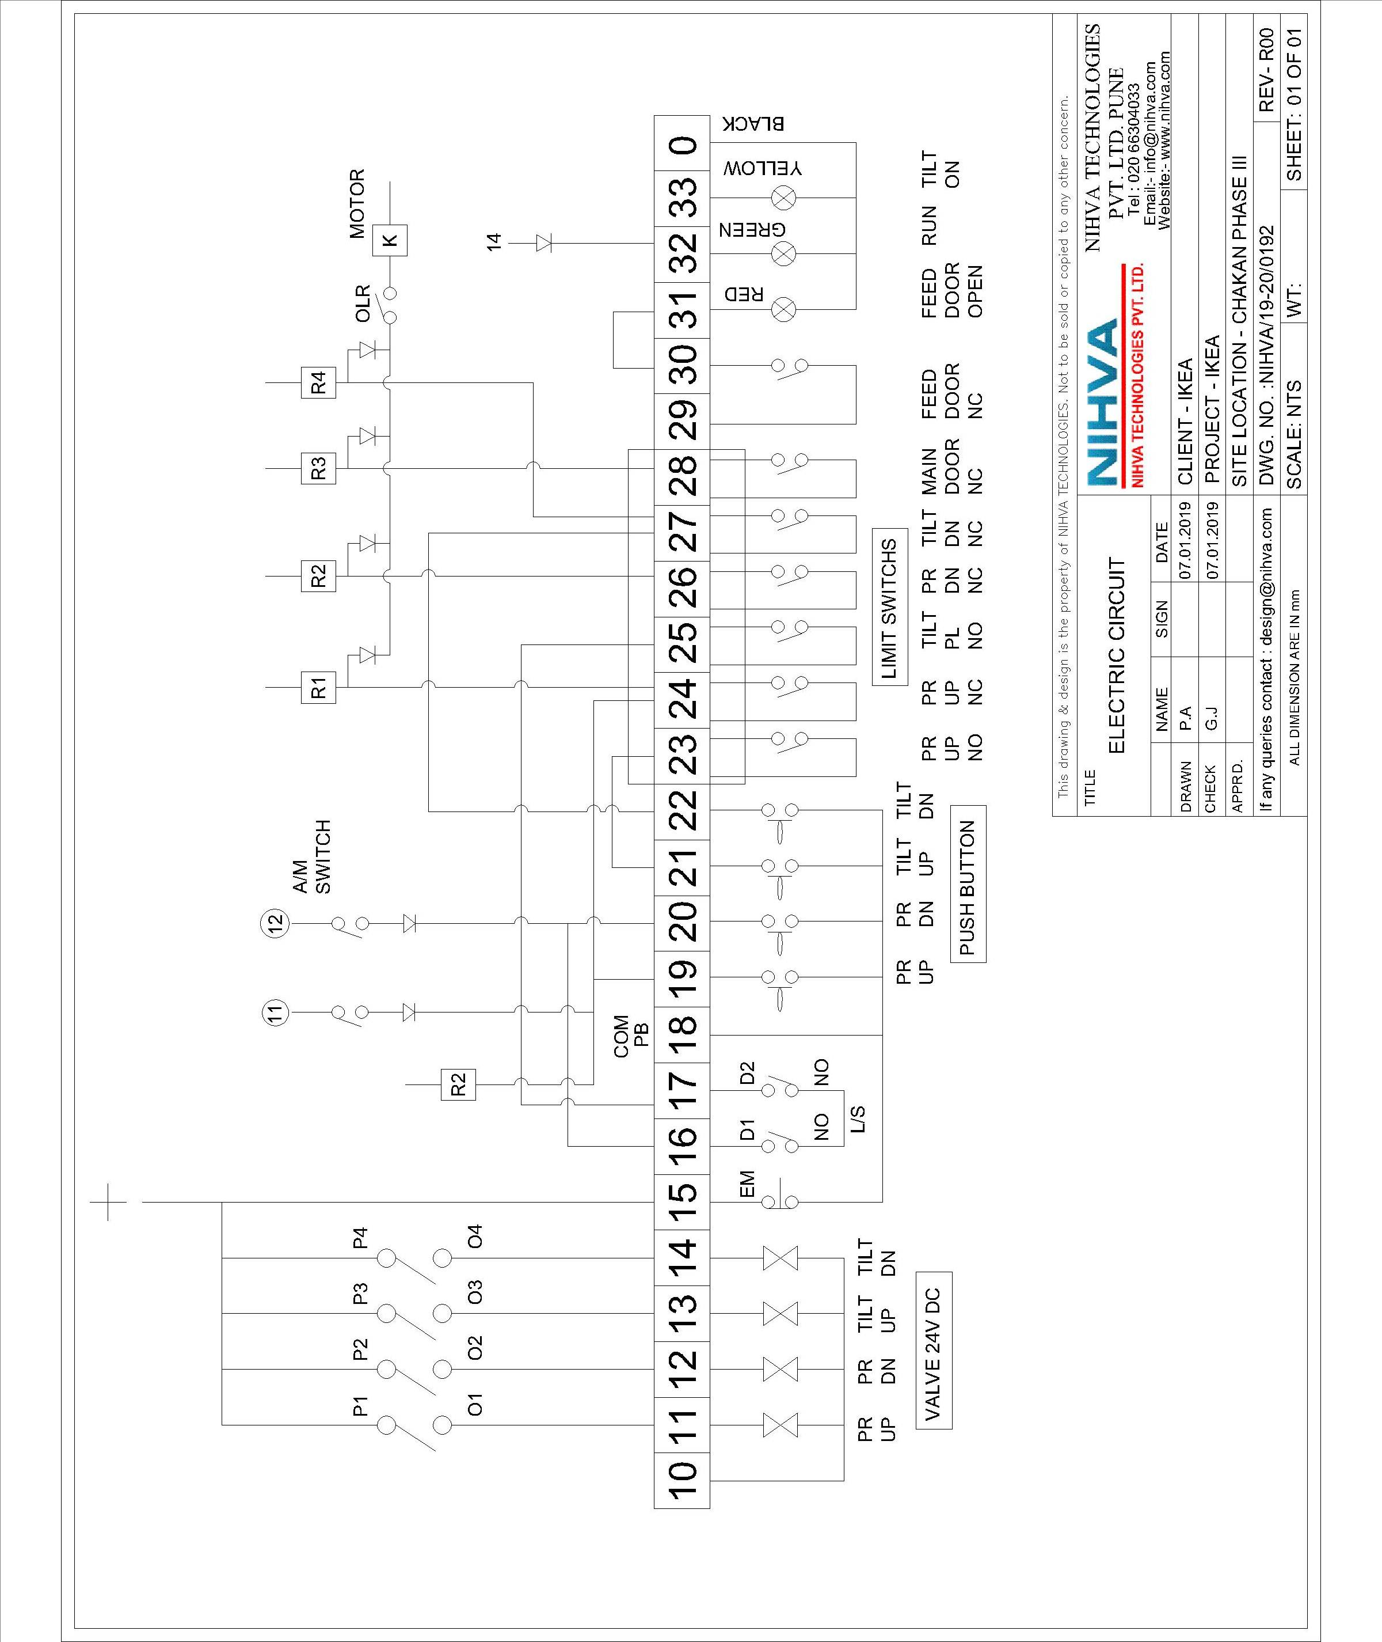

TEST CERTIFICATE
DATE: -

PO.NO: -

TEST NO: -

To,

M/S. IKEA

Sub: -TEST REPORT OF “SINGLE ACTION HYDRAULIC BALING PRESS”.

Here we are enclosing TEST REPORT as given bellow.

SR NO. | DISCRIPTION | REQUIRED |  | TESTED
1 | MAIN CYLINDER CAPACITY | 20 TON |  | 20 TON
2 | OIL TANK CAPACITY | 60 LTR. |  | 60 LTR.
3 | WORKING PRESSURE | 180 BAR. |  | 180 BAR.

NOTE: No leakages are found during the testing of cylinder and working satisfactorily.

NIHVA TECHNOLOGIES PVT LTD

